Forces and Friction - Answers
May 2014 Mathematics Advanced Paper 1: Mechanics 1

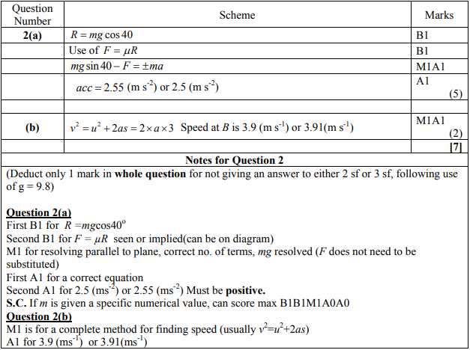

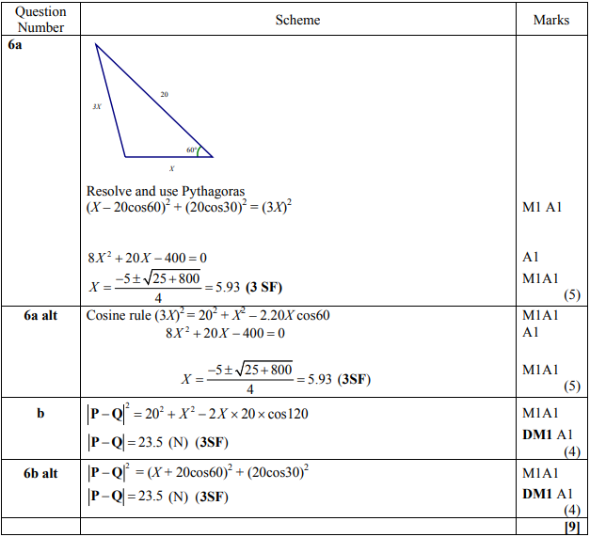
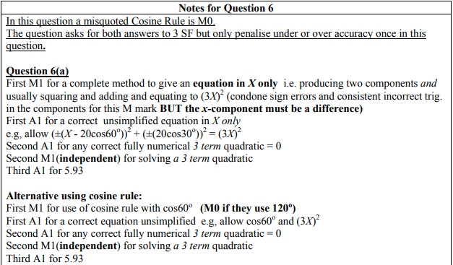
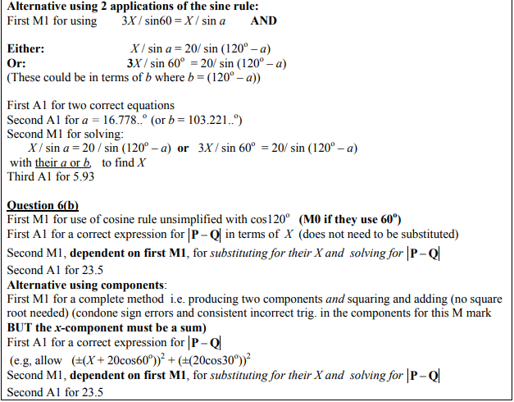
May 2012 Mathematics Advanced Paper 1: Mechanics 1

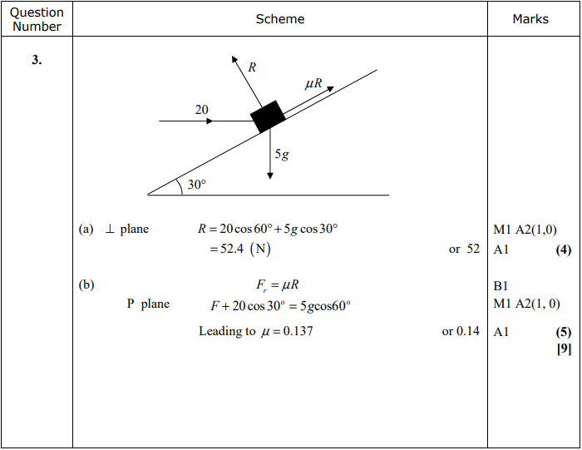
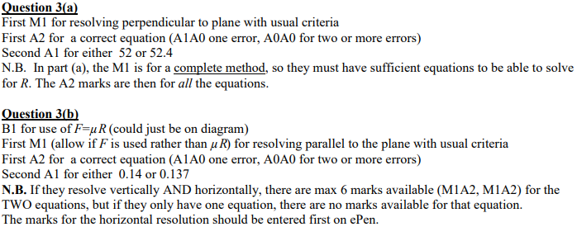

Jan 2012 Mathematics Advanced Paper 1: Mechanics 1

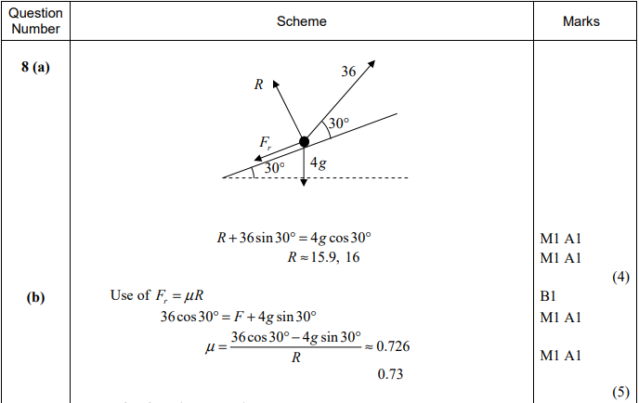
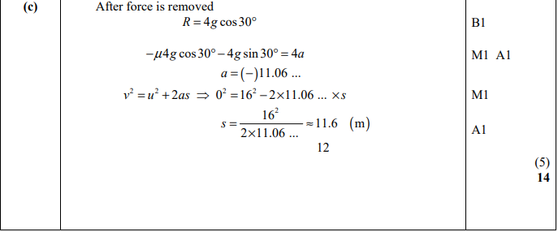

May 2011 Mathematics Advanced Paper 1: Mechanics 1

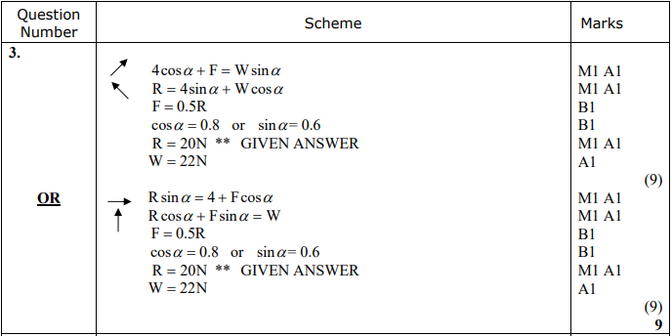

Jan 2011 Mathematics Advanced Paper 1: Mechanics 1

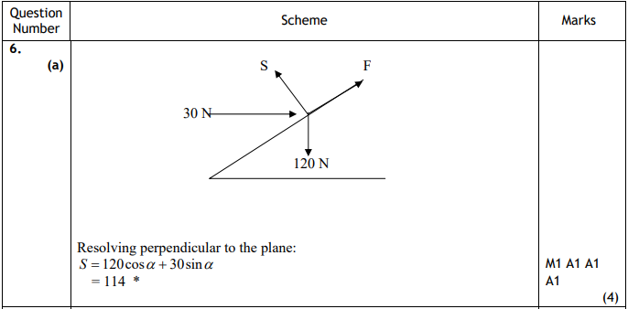
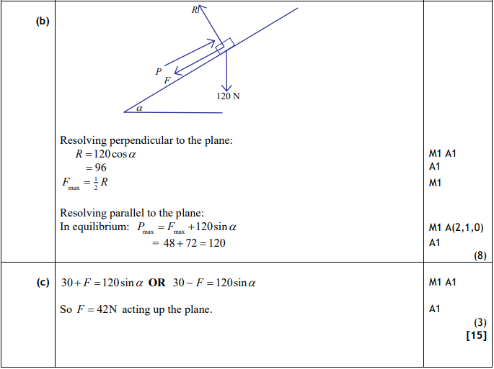

May 2010 Mathematics Advanced Paper 1: Mechanics 1

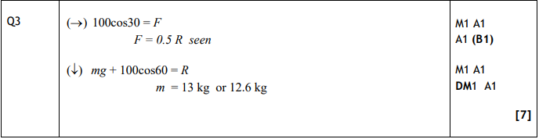

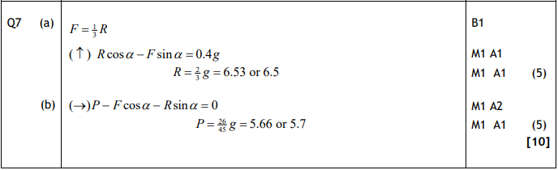

Jan 2010 Mathematics Advanced Paper 1: Mechanics 1

